* Are current design standards for battery installations suitable for the design of large battery banks for marine propulsion (I think the theory is that they are not), what direction is the industry going?
  + Module design is the key aspect to consider the maritime environment, along with high performance requirements of cells. Standard testing regimes for maritime systems are required and sufficiently cover most maritime specific issues (Type Approval [DNVGL-CP-0418](http://rules.dnvgl.com/docs/pdf/dnvgl/cp/2015-12/dnvgl-cp-0418.pdf#search=type%20approval%20cp%200418)).[1] The table below summarizes typical tests required.

|  |  |
| --- | --- |
| **Examples of Cell Tests** | **Examples of System Tests** |
| External short circuit | Propagation / internal thermal event |
| Impact | Overcharge with voltage |
| Thermal abuse | Overcharge with current |
| Overcharge | Overheating control |
| Forced Discharge | Sensor failures |
| **Examples of Environmental Tests** | Cell balancing |
| Vibration | SOC validation |
| Dry Heat | Capacity validation |
| Damp Heat | Safety function test |
| Cold | Dielectric strength (High Voltage test) |
| Corrosion | Insulation resistance |
| Flame retardant | Pressure test of cooling pipes |
| EMC |  |

* + Rack designs that are becoming common in stationary industry are similar to those used in maritime and are regarded as sufficient.
  + Key aspects requiring attention in maritime environment, beyond the above, are safety event handling due to the confined space. This includes module design to protect against propagation and handling of battery offgas.
* Is information on physical dimensions versus power available?
  + Physical dimensions are most directly dictated by energy.
  + Examples from Corvus website (only vendor with publicly available figures for system):
    - 40’ container with just batteries: 1365 kWh (3000+ kW)
    - 40’ container with batteries and power electronics: 819 kWh (1800+kW)
* What are the recharge times?
  + Charge rates are more limited than discharge rates, and are thus less definitively stated by manufacturers.
  + Temperature is the key consideration – higher rates generate more heat. For short periods of time (less heat generated), or when followed by periods of reduced activity (to cool) higher rates are achievable. Higher rates (higher heat generation) can also be expected to reduce lifetime. For this reason, the answer depends heavily on the duty cycle. This is why ‘peak’ rate capabilities are often stated. It also depends on cell design, chemistry, and cooling.
  + A conservative estimate for acceptable limits for constant charge and discharge cycling are likely to be charging in one hour and discharging in 30 minutes. If the cycling is not constant, or either charging or discharging levels are reduced, the other power level may be increased. Maximum full continuous discharge can likely be expected in 10-15 minutes.
  + New, advanced chemistries (titanate, LTO) can perform higher rates (<30 min) while also offering increased expected lifetime.
* Are there any problems with venting/gaseous fumes when recharging?
  + There are significant problems with venting and gaseous fumes, but these are not typically regarded as risks during standard daily operation (charging or discharging). These represent risks during failure scenarios.
  + The explosion - as well as toxicity - risks are substantial. DNV GL has been leading the energy storage industry in assessing safety risks for stationary systems. There are still questions remaining for maritime applications; determining system design requirements, effective mechanisms, and fine tuning testing needs to be done. DNV GL is currently organizing and executing the Maritime Battery Safety Joint Development Project to address these issues with multiple industry partners including NMA (POC: Ben Gully).
* Is any special fire protection required?
  + Once a fire (thermal runaway), has initiated, large amounts of heat absorption is recommended to limit cascading, water is typically the most effective. Fires (depending on chemistry) are self-oxygenating and not easily extinguished. Class rules may require A60 walls, depending on location. Explosion risk from offgas is a primary safety design consideration.
* Recommended charge/discharge cycles for the latest Li chemistries and impact (quantitative) on battery life.
  + Reducing the relative size of the cycle and reducing the power will always benefit battery life. So sizing is key to battery lifetime.
  + Systems are rated based on the size of cycles and number of cycles that can be performed until the battery will have degraded to 80% of its original capacity. Typical chemistries are rated around 8-12,000 cycles at 80% DOD, or around 4-5000 at 100% DOD
  + Titanate chemistries are available for much higher cycle rating, almost 10 times that of NCM.
  + Lifetime is closely related to sizing and is a complex question – such as what constitutes a ‘cycle’ during actual operation which is typically highly variable. DNV GL has developed BatteryXT and engaged in (ongoing) extensive testing programs to understand and assess these issues. POC: Ben Gully
* Charge acceptance rates (like the plot attached, not c-rate) to calculate time to charge for the latest Li chemistries.
  + The plot attached represents typical lab test conditions. Most field batteries will be using a reduced amount of total energy (less than 100% DOD) and is not uncommon to charge at a constant rate – for instance the constant slope of the ‘charge capacity’ line before it levels off close to 100. These rates are extremely dependent on chemistry (vendor) and system design (air vs liquid cooling) but again, charging is typically much more limited than discharging and limitations depend heavily on how consecutively charging and discharging is performed. See above for typical rates (Bullet 3).
* What is status of battery power density improvements (store more energy and reduce size)?
  + Performance at the cell level is accelerating quickly. See Bullet 2 for state of technology at full (containerized) scale. For reference, a couple years ago we were testing 40Ah cells. Now we are testing 75Ah cells of almost indiscernible size difference.
* What are the latest cooling methods?
  + Air cooling is still the most common solution, but many companies offer alternatives such as liquid cooling. Requirements depend on power levels and system design, but quality thermal management produces many benefits. Some designs use specific highly conductive materials (solid state) to remove heat from cells. Other designs may use direct liquid cooling.
* At a battery symposium at NAVSEA Carderock a few years ago.  The objective was to make batteries more power dense; however they had to be less flammable.  Based on materials at that time, these were diverging objectives. Are they still?
  + Flammability levels are due to electrolyte and cathode chemistry. Many of the materials used for both of these components have remained the same, but advancements in manufacturing and tweaks to chemical composition have significantly increased energy and power density. Regardless, packing a greater amount of energy into the same volume of space will increase the risk/threat level.

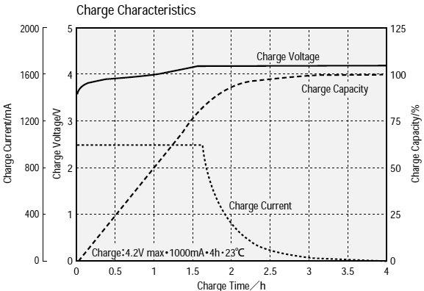

1. DNV GL class rules also free/publicly available: <http://rules.dnvgl.com/docs/pdf/DNVGL/RU-SHIP/2016-07/DNVGL-RU-SHIP-Pt6Ch2.pdf>