Form Approved: OMB No. 2133-0529
This collection of information is required to obtain a waiver of the U.S.-build and other requirements of the Passenger Services Act (46 U.S.C. 55103) and will be used by the Maritime Administration to determine if the applicant is entitled to a waiver. Public reporting burden is estimated to average one hour per response, including the time for reviewing instructions, searching existing data sources, gathering and maintaining the data needed, and completing and reviewing the collection of information. No assurances of confidentiality are provided. Please note that an agency may not conduct or sponsor, and a person is not required to respond to, a collection of information unless it displays a currently valid OMB control number. The OMB control number for this collection is 2133-0529.
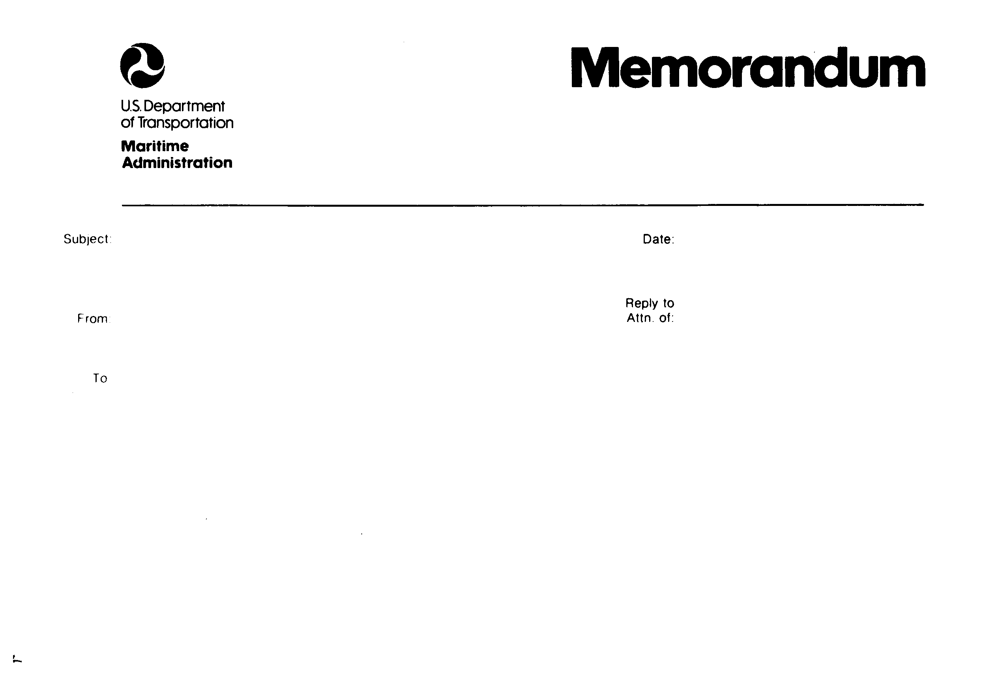
REQUEST FOR ADMINISTRATIVE WAIVER OF THE JONES ACT
46 U.S.C. 12121, 46 C.F.R. 388
1. Name of the Vessel:

2. Owner Information:

Name: ________________________________ Telephone No: ________________________ ___ __
Address: _______________________________ _ Email: ___ ____________________________ ____
3. Vessel Official Number (or Hull Identification No., or State No.):
4. Base of Operations: .
5. Date of vessel Construction:
6. Place of Construction:
7. Vessel Type, Size, Capacity and Net Tonnage of the vessel. Net tonnage as measured per federal regulations. See instructions for guidance.
Vessel Type: ___ ________ (ex. sail, catamaran, hovercraft, motor, etc.)
Size: _____________ length
Capacity: _____________ passengers
Net Tonnage: _______ ____
8. Intended commercial use of the vessel (attach pages if needed):

9. List all State(s) of intended operation and trade (No more than two U.S. coasts):
States: ___ ________
Base of Operations (i.e., homeport): ___ ___ __

10. A statement on the impact this waiver will have on other commercial passenger vessel operators: A statement on the impact this waiver will have on other commercial passenger vessel operators. Including a statement describing the operations of existing operators (attach pages as needed):

11. A statement on the impact this waiver will have on U.S. shipyards. Note: we may use the following criteria to determine the effect on U.S. vessel builders: Whether a potentially affected U.S. vessel builder has a history of construction of similar vessels, or can demonstrate the capability and capacity and the fact it has taken definite steps to offer to build a similar vessel, for use in the same geographic region of the United States, as the proposed vessel of the applicant. (attach pages as needed):

12. By submitting this information you are deemed to have certified that the above information is true and correct:  13. Submit your $500.00 payment via:  https://www.pay.gov/paygov/forms/formInstance.html?agencyFormId=1071542 website. | 14. Email to SmallVessels@dot.gov  or Mail to:  Small Vessel Waiver Program  Maritime Administration  MAR-620, MS #2 W23-465  1200 New Jersey Ave., SE  Washington, DC 20590
FORM MA-1023 (11-10)

